主标题:uhf rfid pda
副标题：HT540-uhf rfid reader android
Key features:
2.0GHz Octa-Core processor for fast performance
Android 10.0 operating system
UHF RFID: Reading distance of 1-3 meters (tag and environment related)
1D/2D barcode scanning capabilities
4G communication,Dual-band Wi-Fi and Bluetooth for seamless connectivity

uhf rfid pda-1
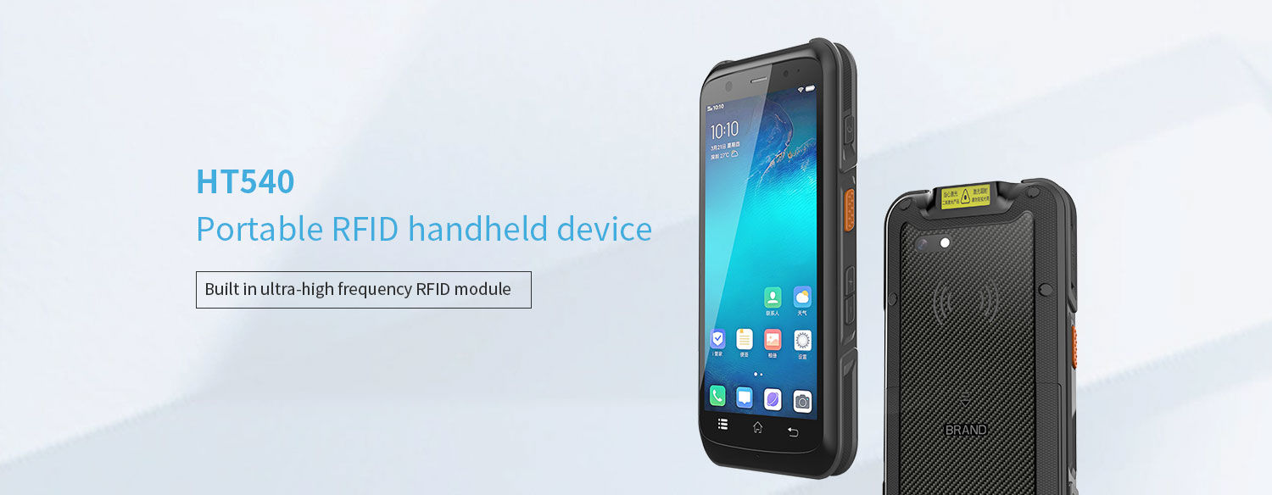
5.5 inch Industrial Rugged android pda rfid reader
• The HT540 android uhf rfid pda is equipped with a powerful eight core MediaTek MT6762 CPU, with each core running at a maximum frequency of 2.0GHz, ensuring fast task processing. In addition, it is equipped with 4GB RAM and 64GB internal storage space, allowing for smooth switching between 15-20 active applications.
• The HT540 handheld rfid reader supports optional ultra-high frequency RFID modules, high-frequency RFID modules, and low-frequency RFID modules.
• [Optional Scanning Function]: The HT540 Android handheld RDID tag reader supports optional TMS-E60 scanning head, and the Honeywell HS7 supports a motion tolerance of 6 meters per second (236 inches/second), allowing it to scan barcodes on moving items on conveyor belts. Zebra SE4710 scanning head can also be optionally selected.
• The HT540 RFID handheld terminal has an IP65 protection level and is dustproof and splash proof. It also supports a 1.2-meter drop resistance, making it durable even in harsh environments such as warehouses or logistics operations.
uhf rfid pda -2
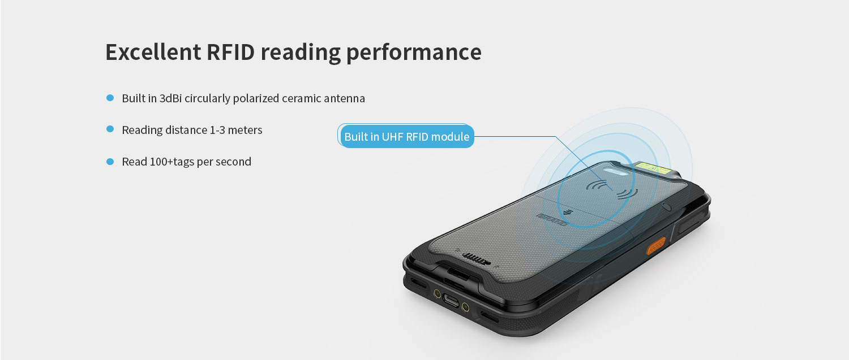
The HT540 handheld rfid reader terminal supports optional ultra-high frequency RFID modules.
UHF RFID: Built in UHF RFID module, readable and writable, with a distance of 1-3 meters (tag and environment related)
Frequency: 865-868 MHz/920-925 MHz/902-928 MHz
Protocol: EPC C1 GEN2/ISO 18000-6C
Antenna: 3dBi doubly fed point RFID circularly polarized ceramic antenna
uhf rfid pda-3
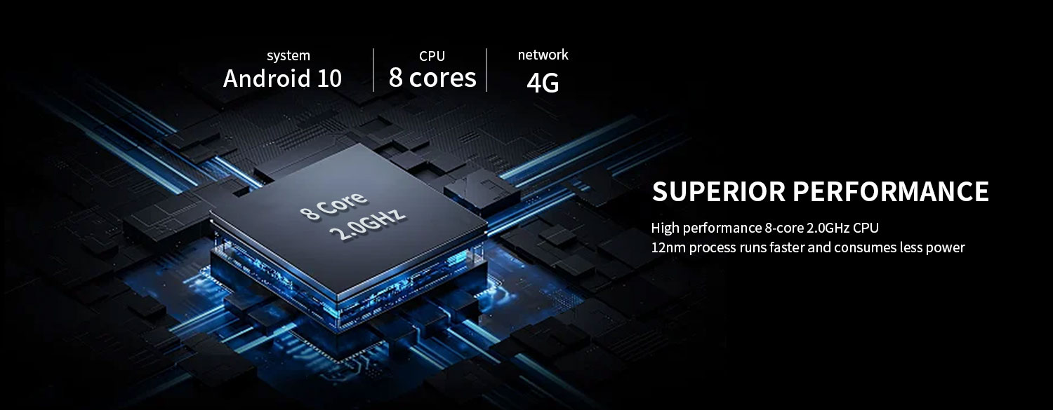
High performance CPU
MT6762 CPU: Experience the powerful performance of MediaTek MT6762, designed specifically for seamless multitasking on your PDA device.
Standard memory 2G+16G, optional 4GB+64GB: Use a high memory warehouse scanner to provide ample storage space for all your applications and files.
uhf rfid pda-4
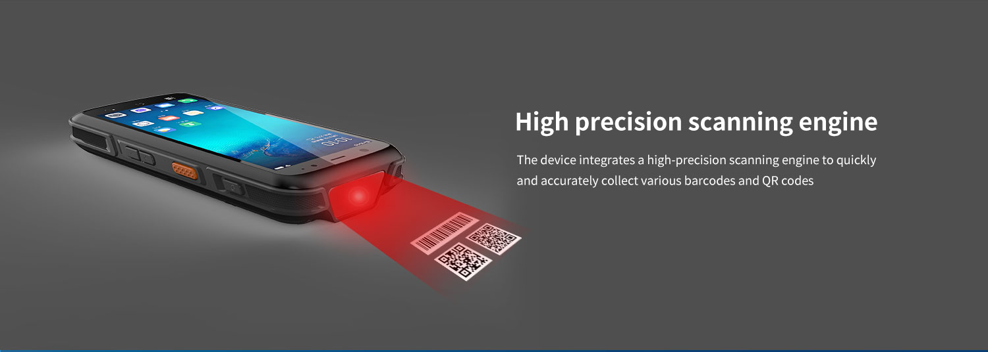
scanning engine- optional
The HT540 uhf rfid pda optional TMS-E60 scanning engine, with high brightness LED providing exposure assisted lighting, allowing for quick barcode recognition even in completely dark conditions. TMS-E60 provides laser aiming indicator patterns to assist users in aiming at targets, facilitate barcode recognition, and improve recognition efficiency. Capable of reading the most commonly used barcodes in the retail, logistics, and healthcare industries, such as Code 11, Code 128, PDF417, EAN codes, etc. It even supports scanning damaged barcodes and screen barcodes.
Supports optional Honeywell HS7 (with a motion tolerance of up to 6 meters/second (236 inches/second), capable of effectively reading moving barcodes), and also optional Zebra SE4710 scanning head.
uhf rfid pda-5
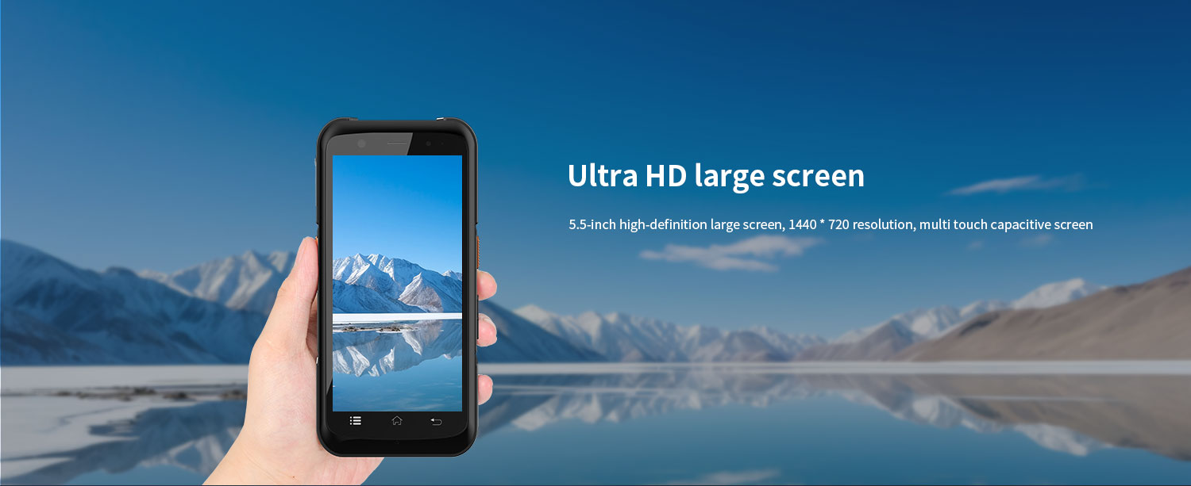
The HT540 uhf rfid pda is equipped with a 5.5-inch touch screen, which allows for normal keyboard operation even when hands are wet or gloves are worn, making it more widely applicable.
uhf rfid pda-5
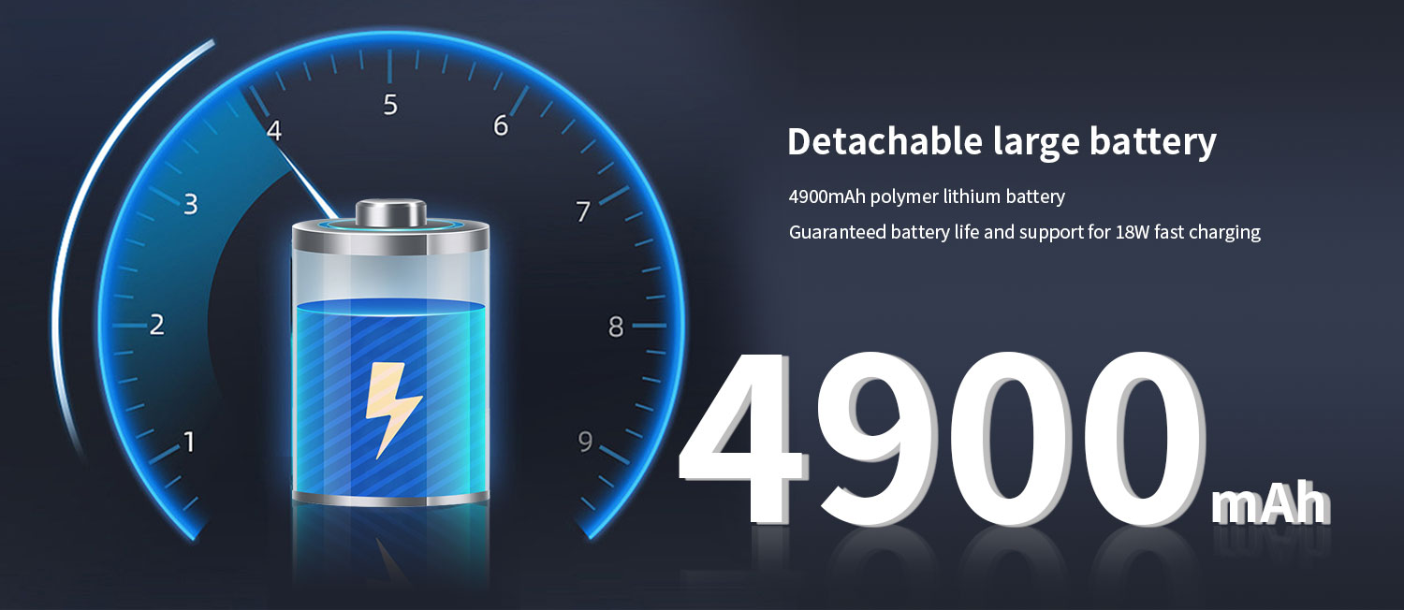
uhf rfid pda-6
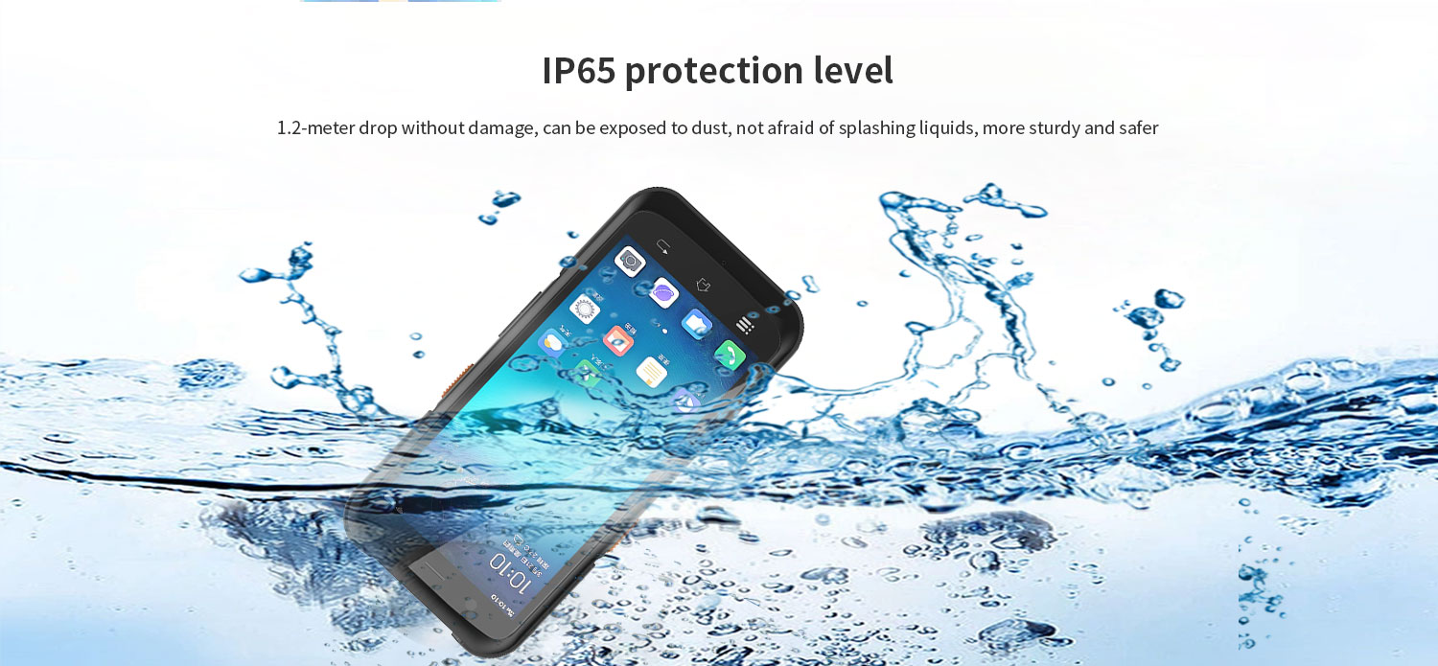
IP65 protection level
1.Dustproof: Fully enclosed design to prevent dust from entering and ensure the safety of internal components.
2.Waterproof: This HT540 uhf rfid pda has splash proof function, but should not be immersed in water.
NFC function
NFC function: This Android handheld mobile RFID reader has built-in NFC function, which can seamlessly communicate and transmit data in industrial environments. Very suitable for inventory management, employee identification, and access control.
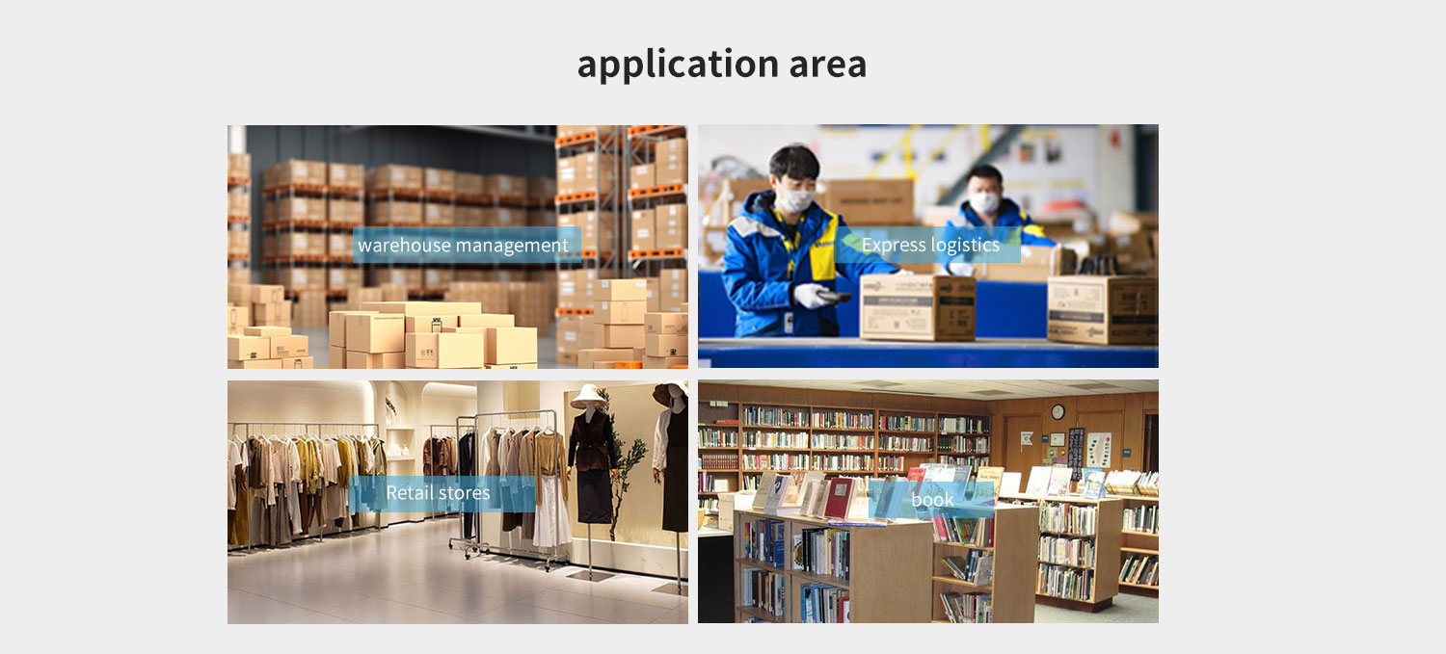

Provide ODM and OEM customized services
We work closely with our partners and can provide various one-stop customized solutions.
Appearance customization: supports customization of product nameplates, product packaging, and promotional materials.
Hardware customization: Supports customization of functional modules and optional hardware functions.
Software customization: supports customization of boot interface, boot program, kernel clipping, and API interface.
Technical support: Provide SDK development kits and application software development technical services.

HARDWARE CUSTOMIZATION
1: Nameplate Logo Customization
2:Packaging Custom Design
﻿
SOFTWARE CUSTOMIZATION
1:Boot Screen Customization
2:System Function Hiding
3:Built-in Customer App
4:Customer App Auto-launch
5:Platform Software Integration
6:Fixed MAC Address
7:Download Prohibition
﻿8:USB Disablement
﻿9:APP Installation and Uninstallation Control
10:Pre-installed APK
﻿11:Camera Control
12:Provide System Signing Files

frequently asked questions
Q: Are you the original manufacturer?

A: Yes, we are the original manufacturer. We have our own brand LQYCIT. All of our products have complete patented ID/MD designs, hardware and software, molds, and assembly are all completed by our own team.

Q: Can you pre install our software?

A: Yes, we can pre install your software.

Q: What is the minimum order quantity?

A: We accept standard product orders starting from one unit. If necessary, we can even customize your logo. For OEM, our sales team will review the detailed requirements and confirm the minimum order quantity.

Q: Can we get free samples?

A: Sorry, we usually do not provide free samples. If the customer confirms the specifications and pricing, they can first order samples for testing and evaluation.

Q: How to place an order and make payment?

A: We accept wire transfers (bank transfers), Alibaba online payments, and Western Union remittances.

Q: What is the warranty period for your products?

A: We offer a 12-month warranty after shipment.

Q: How long is the delivery time?

A: The production delivery cycle is about 3-10 days, depending on the requirements. The delivery time through DHL/UPS/FedEx/TNT is approximately 3-5 working days. For some remote areas, the transportation time may be longer.

Q: How to fix equipment problems?

A: We will provide online technical support to solve problems. For hardware issues, we can ship parts or components for customers to install (if they have technicians), or we can ship them back to us for repairs.

